TCD/MBC/FPR/Coolant sensor installation guide.

Some tools and equipment you’ll need:

X-acto knife or razor blade
Electrical tape
Zip ties
Soldering iron
Solder
Steady hands
Male and female spade terminals or switch

A boost gauge and a diagnostic tool such as VAG-COM is very handy in the diagnosis of your performance and whether or not you’re getting throttle cut.

- Remove the s4biturbo engine cover above the throttle body area
- Cut back some of the black sheathing on the MAP sensor wiring that goes to the sensor on the throttle body boot

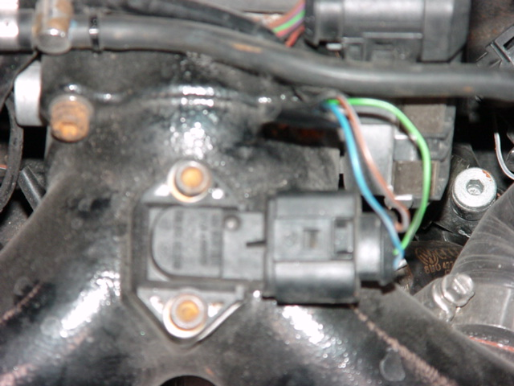

- Cut out a small section of wire insulation, say, around ¼”, on the brown wire and on the blue/grey wire. DO NOT break the wiring here. The wire is of a fine gauge, so, be careful in order to not damage the strands.

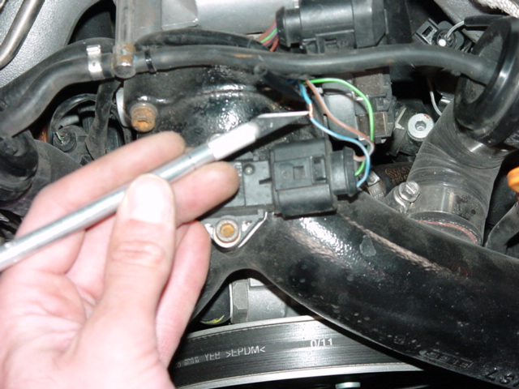

- Splice the TCD in parallel with these wires, blue of the TCD goes to blue-grey and brown of the TCD goes to brown of the MAP sensor wiring.
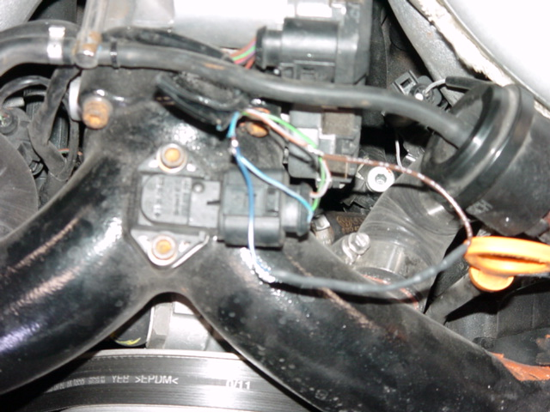
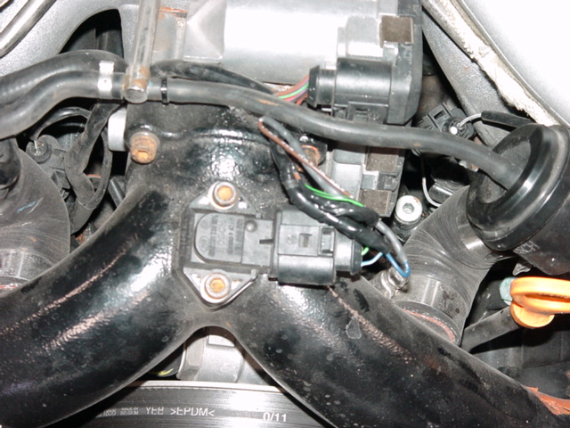

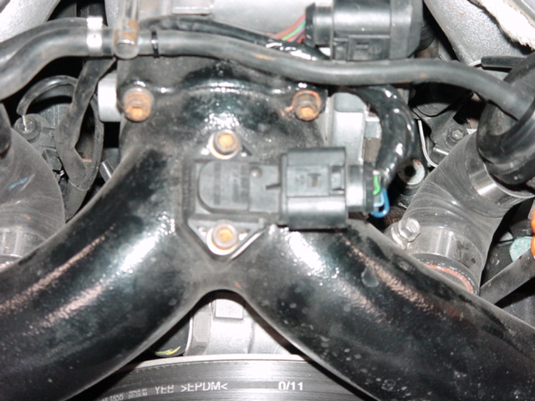
- OPTIONAL: you may follow these wires back to the engine computer and install it in your Engine computer compartment.
- OPTIONAL: you may put in some terminals on one of the wire ends in order to be able to disconnect or switch off the TCD.

Manual Boost controller pictures:
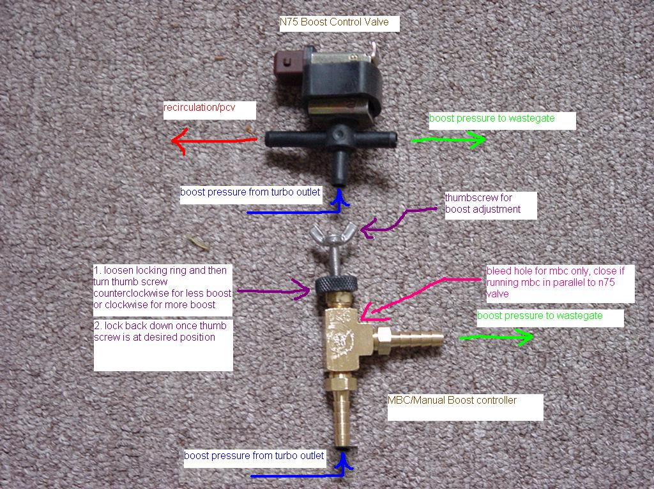

Installed in vehicle, MBC ALONE. If ran in parallel to the N75 to clip boost spikes, must use ¼” tees and vac hose and follow diagram above.
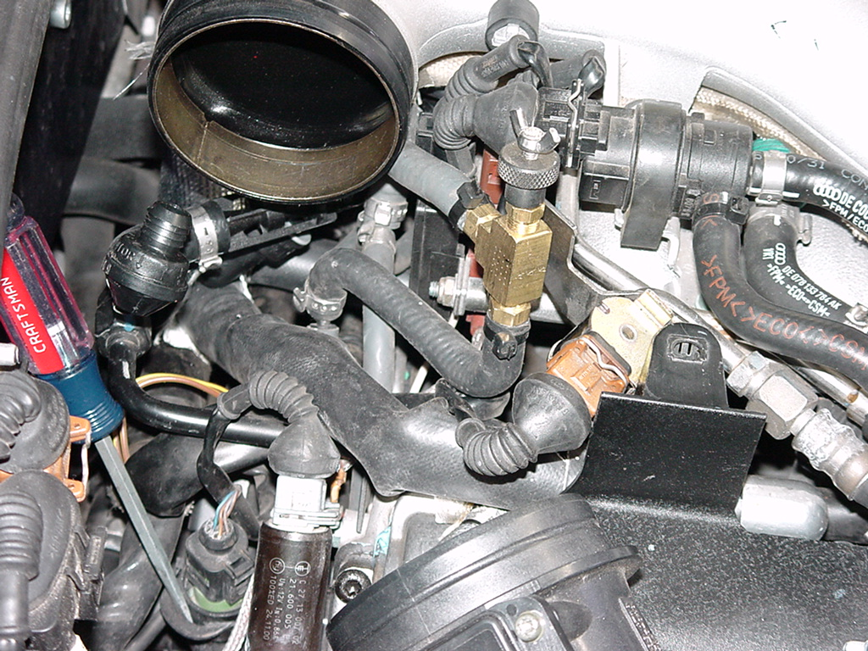

Location of Fuel Pressure Regulator. Remove clip with screwdriver and twist and pull fuel regulator out. It can be difficult. Be sure that there is no fuel pressure (can run motor and pull fuel pump fuse (#28)) until motor dies.
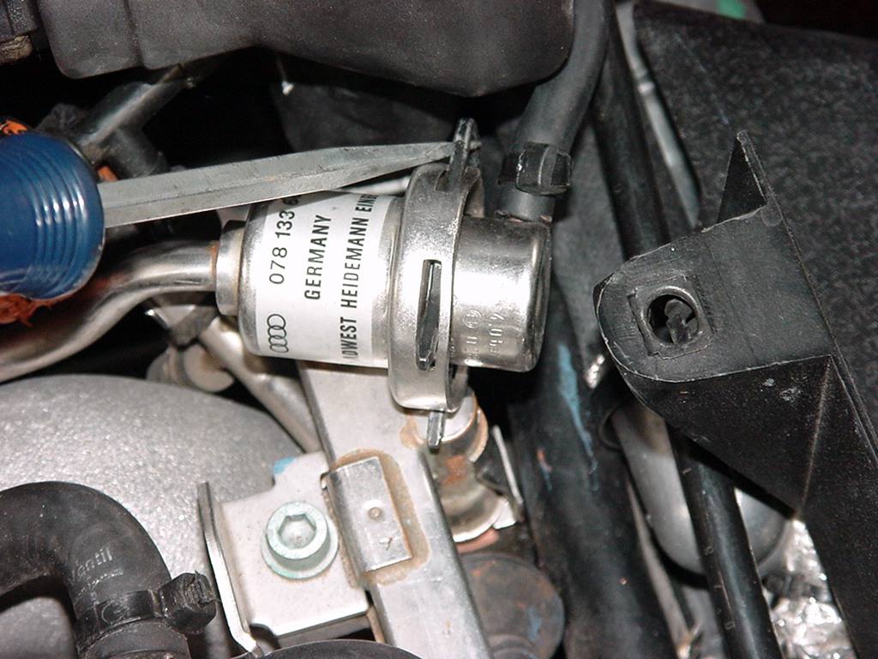

Lube o-rings with a very thin film of oil or grease or fuel and using the same twisting motion, re-install.
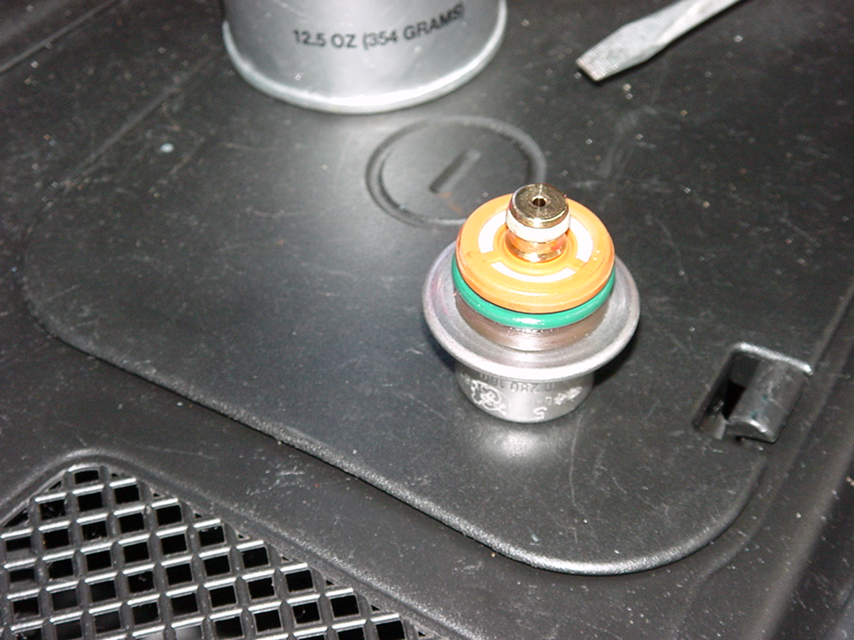

Location of coolant sensor. Pry clip out and then pull sensor straight up. Make sure the old O-ring comes out as well. Then stick a rag in the pipe to clean out all debris. Lubricate the new O-ring and install new coolant sensor with a new clip. Be careful when using a screwdriver to unclip the wiring connector. The UPDATED coolant sensor is green and is recommended over the old black one.



